Below is the script used to finalize the result-

**Pig –x local;**

**emp_details = LOAD '/home/acadgild/pig/employee_details.txt' USING PigStorage(',') AS (emp_id:int, name:chararray, salary:int, rating:int);**

**emp_expense = LOAD '/home/acadgild/pig/employee_expenses.txt' USING PigStorage('\t') AS (emp_id:int, expense:int);**

**joined_data = JOIN emp_details by emp_id FULL, emp_expense by emp_id;**

**filter_res = FILTER joined_data BY emp_expense::emp_id IS NULL;**

**final_result = FOREACH filter_res GENERATE $0, $1;**

**dump final_result;**

Each and every relation has been explained below with its immediate corresponding output-

Start pig in local mode-

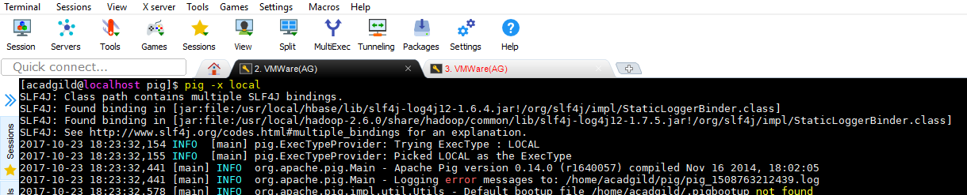

Load the emp_details.txt file using PigStorage

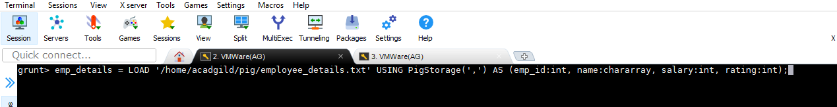

Contents of file-

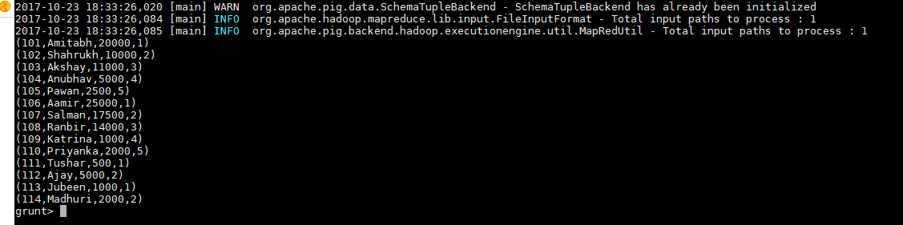

Load the emp_expense.txt file using PigStorage

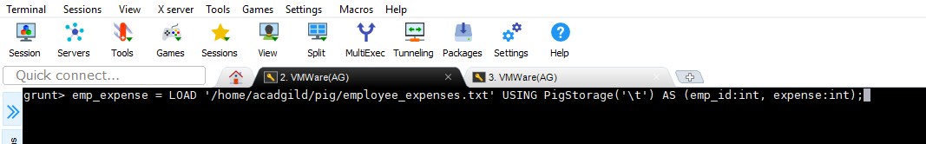



Contents of file-

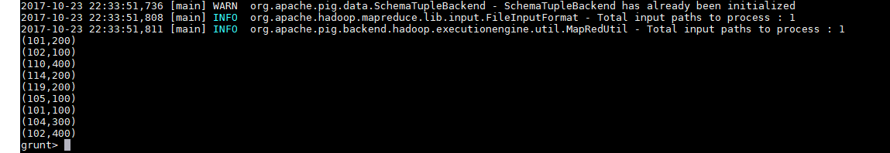

Do a FULL OUTER join on both files -

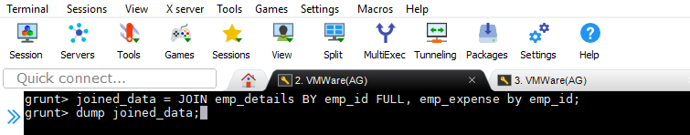

Result of FULL OUTER JOIN-

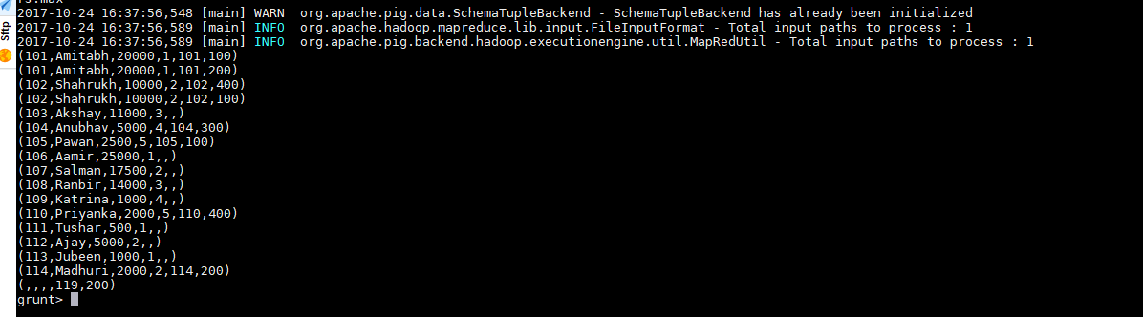

Check whether contents(emp_id) from second file(emp_expense) is NULL and FILTER them-

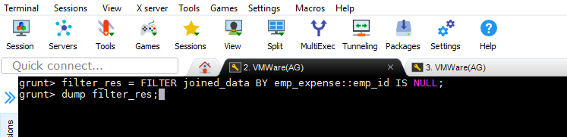

Result of Filtered out data which are not present in emp_expense file-

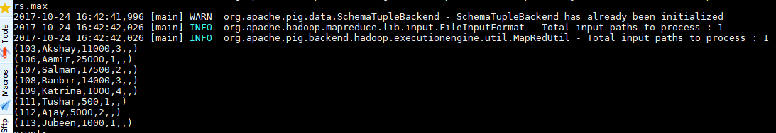

Extract emp_id aand emp_name from first file as required

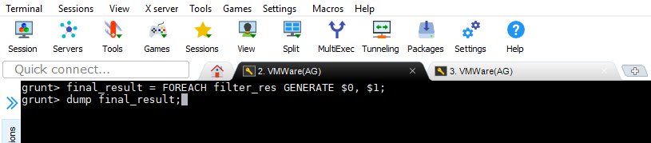

**Final O/P-**

